# Problem E

# Spread and Development of Metropolitan Areas

The metropolitan area which our chose is Los Angeles.

The task of our team is to create a set of quantitative support models to evaluate the various impacts of the expansion of urbanization. First, we have defined important indicators and evaluation criteria: population and GDP per capita. We use GDP and population as the main indicators. Based on the increase in cancer population, the loss caused by the metropolitan area was evaluated. Finally, the impact of urbanization on food security is considered through the annual farmland output.

1.

Considering that the number of cars in a city is related to the city's population and the disposable income of residents, the data of Los Angeles population and per capita GDP from 2106 to 2019 are linearly fitted to its impact on the number of cars, and then the corresponding year is predicted Car ownership.

DATASET：

|  |  |  |  |
| --- | --- | --- | --- |
| DATE | CALOSA7POP(Thousand) | GDP per citizen | number of cars |
| 2010/1/1 | 9823.246 | 43594 | 11,412,659 |
| 2011/1/1 | 9876.482 | 46470 | 11,433,755 |
| 2012/1/1 | 9935.375 | 49525 | 11,470,565 |
| 2013/1/1 | 9992.484 | 49157 | 11,543,124 |
| 2014/1/1 | 10040.072 | 52272 | 11,591,690 |
| 2015/1/1 | 10085.416 | 55578 | 11,671,288 |
| 2016/1/1 | 10105.708 | 57538 | 11,878,573 |
| 2017/1/1 | 10103.711 | 59625 | 12,074,796 |
| 2018/1/1 | 10073.906 | 62300 | 12,383,481 |

Form 1

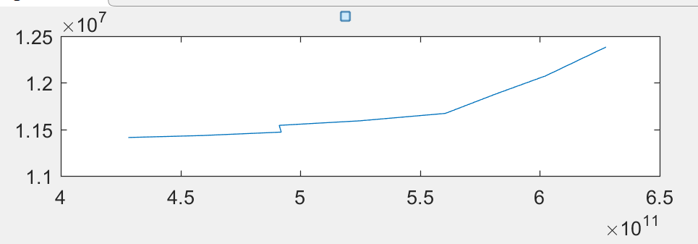

*Figure 1*

It can be observed through the *figure 1* that the relationship is slightly linear

The car ownership in a region is generally linearly related to the economic level of the region, so here we use the economic aggregate and car ownership to perform a linear fit by the least square method.

Define the relationship between economic aggregate and car ownership as followed:

Y=AX + B

Fitting result :

A = 4.51237444194451e-06

B = 9327571.92687742

Therefore, it is easy to know that the population growth brought about by the development of big cities and the economic aggregate growth will lead to the increase in the number of cars.

2.

The expansion of urban area and the increase of urban population will lead to increased living environment pollution of residents, such as air pollution and water pollution, and will lead to an increase in unhealthy eating rates. All of these will lead to an increase in the prevalence of chronic diseases among residents, which in turn will cause the government to increase expenditures on medical and environmental treatment and increase additional losses.

Here we use cancer expenditure to count the losses caused.

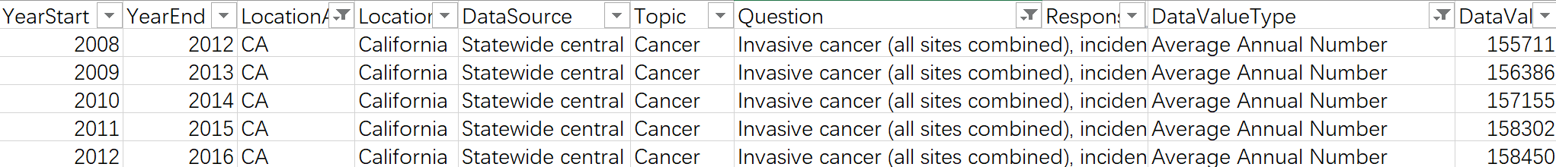

Form 2

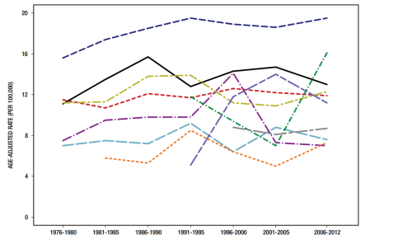

Figure 2

It shows that the proportion of cancer patients from 2008 to 2012 has increased year by year.

According to the statistical report of the U.S. Census Bureau, the average cost of cancer in the United States is $150,000.

In order to protect the privacy of residents, the CDC updates statistics on cancer every 5 years and then releases them uniformly. Therefore, there is not data about recent years.

Due to the small amount of data, it is more appropriate to adopt the GM(1,1) to estimate the loss in the short term. Forecast the growth of cancer call charges in the next five years

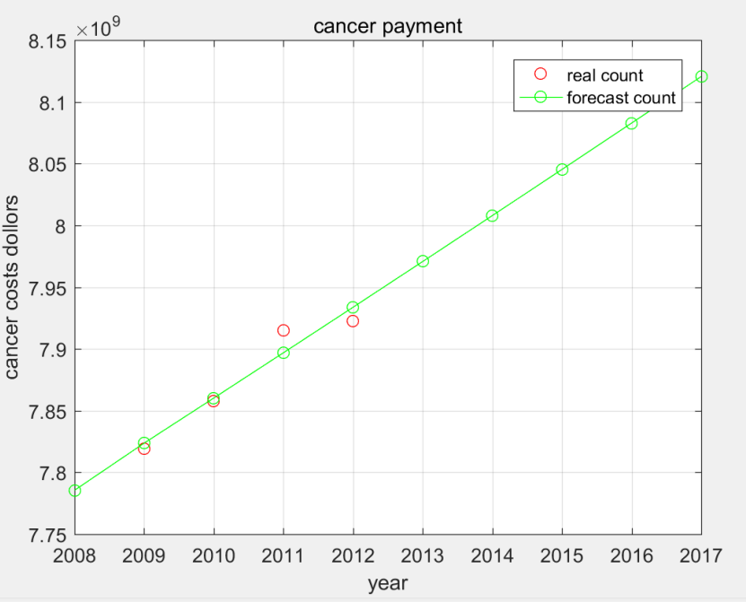

Figure 3

Relative residual Q=0.000920110933168094

Variance ratio C = 0.184849276621288

Probability of small error P=1

The prediction result is relatively accurate

It can be seen that the annual expenditure increases on an annual basis of 5*10^7 dollars.

3.

We mainly use Los Angeles’ per capita annual income and permanent population to measure the city’s development prospects, using the data sets "per capita personal income.csv" and "Permanent population (thousands).csv" to predict based on previous records. Per capita annual income and permanent population in the next 5 years (2020-2024).

For the forecast of per capita annual income in the next 5 years.

Programs used: GDP.m, predict_GDP.m.

Data set "Per capita personal income.csv" description:

The format of this data set is as follows, which counts the annual per capita income (USD) of Los Angeles in a total of 51 years from 1969 to 2019.

|  |  |
| --- | --- |
| DATE | PCPI06037 |
| 1969/1/1 | 4819 |
| 1970/1/1 | 5059 |
| 1971/1/1 | 5226 |
| 1972/1/1 | 5684 |
| 1973/1/1 | 6130 |
| 1974/1/1 | 6693 |
| 1975/1/1 | 7282 |
| ... | ... |
| 2019/1/1 | 65094 |

Form 3

Forecast methods and selected models:

The relationship between changes in per capita annual income over time using matlab is as follows:

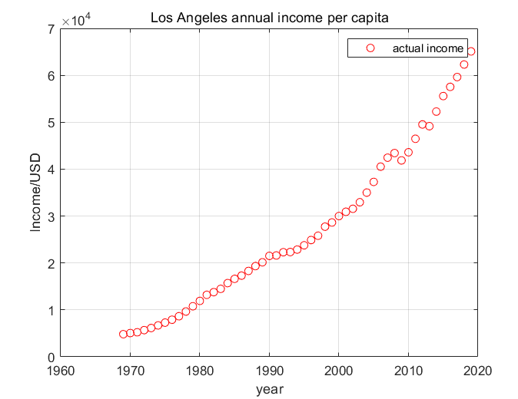

Figure 4

Observed that this is a non-linear relationship, and the forecasting time is relatively short, the GM(1, 1) model is selected for forecasting for the six years from 2020 to 2024. The main idea of the GM(1, 1) model is to use the original data to form the original sequence (0), and generate the sequence (1) by the accumulation method. It can weaken the randomness of the original data and make it show more obvious characteristic laws. To generate the transformed sequence (1), create a differential equation model, that is, a GM model. The GM(1,1) model represents a first-order, 1-variable differential equation model.

The test method here uses the relative error size test method



If all |ε(k)|<0.1, it is considered to meet the higher requirements; if all |ε(k)|<0.2, it is considered to meet the general requirements. The relative error Q = 0.1229 calculated by modeling, the effect is better.

Forecast curve and actual curve

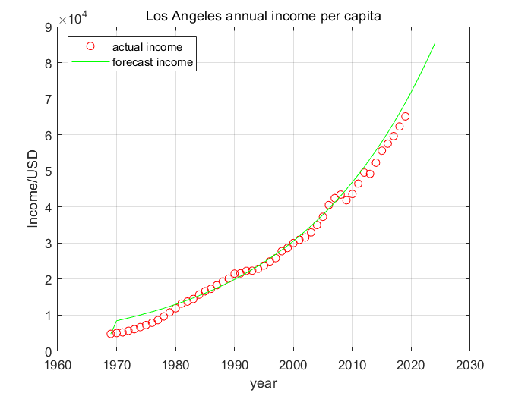

Figure 5

The final forecast for 2020-2024 per capita income is as follows:

|  |  |
| --- | --- |
| year | Forecast per capita annual income |
| 2020 | 71918 |
| 2021 | 75061 |
| 2022 | 78341 |
| 2023 | 81765 |
| 2024 | 85338 |

Form 4

It is predicted that the average growth rate of per capita income from 2020 to 2024 will be:

|  |  |
| --- | --- |
| Year | Growth rate compared to the previous year |
| 2020 | 16.6% |
| 2021 | 4.4% |
| 2022 | 4.4% |
| 2023 | 4.4% |
| 2024 | 4.6% |

Form 5

Average growth rate r = 6.88%

Forecast of the permanent population in the next 5 years.

Programs used: population.m, predict_popupation.m

Data set "Per capita personal income.csv" description:

The format of this data set is as follows, which counts the permanent population (thousands) of Los Angeles in a total of 50 years from 1970 to 2019.

|  |  |
| --- | --- |
| DATE | CALOSA7POP |
| 1970/1/1 | 7041.982 |
| 1971/1/1 | 7103.6 |
| 1972/1/1 | 7056.6 |
| 1973/1/1 | 7040.4 |
| 1974/1/1 | 7085.8 |
| 1975/1/1 | 7116.8 |
| ... | ... |
| 2019/1/1 | 10039.107 |

Form 6

Forecast methods and selected models:

After using matlab to make the relationship of the permanent population over time, it is found that the graph is similar to the S-shaped curve. The increase of the permanent population is fast and then slow, which is in line with the application of the retarded growth model (Logistic model), so logistic is selected for modeling :



xm represents the total population capacity, x0is the population of the initial statistics, r is the population growth rate, the concrete realization of this formula is realized by population.m. The initial value x0 = 7041.982 (the statistical population in 1970), and the final plan The combined effect is as follows:

5.

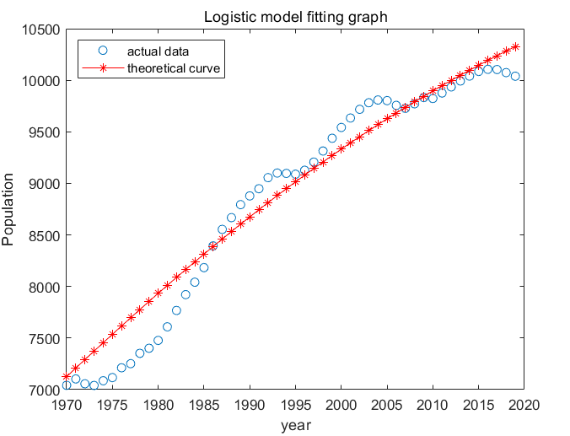

Figure 6

The fitting effect is better. The final forecast of the permanent population for 2020-2025 is as follows:

|  |  |
| --- | --- |
| year | Forecast permanent population |
| 2020 | 10370 |
| 2021 | 10413 |
| 2022 | 10454 |
| 2023 | 10495 |
| 2024 | 10535 |

Form 7

Through the above prediction and analysis of Los Angeles' per capita GDP and permanent population in the next five years (2020-2024), it can be concluded that the per capita GDP growth rate is expected to maintain 6.88% in these five years, which is a considerable growth rate. The resident population remains at around 10.45 million. According to our country’s current classification standards for cities, a megacities with a resident population of more than 10 million. Judging from these two indicators, the development prospects of Los Angeles in the next five years are very good.

4.

5.

After forecasting through our modeling and collecting relevant data, we came to the following conclusions,

As the second largest city in the United States after New York, Los Angeles has a rapid population growth in the past ten years, and it is predicted

In the five years from 2020 to 2024, the average resident population growth rate reached 6.88%, which means that the city’s resident population will remain above 10 million. The resident population is very large. On the one hand, it shows that the city has very good development prospects, but at the same time it also brings some problems, such as the relatively rapid growth of the number of private cars, which brings relatively large traffic pressure. After modeling and analysis, it is also found that the city’s cancer medical expenditure is increasing year by year, part of which is due to the health problems of residents caused by environmental problems caused by population growth. At the same time, due to the expansion of cities, the area of arable land is also decreasing, which brings hidden dangers to food safety. Therefore, we suggest that Los Angeles should mainly control the number of resident population, while developing public transportation, pay attention to protecting the ecological environment, control the expansion speed of the city, and ensure the basic farmland area.